Irish Quiz Questions 3
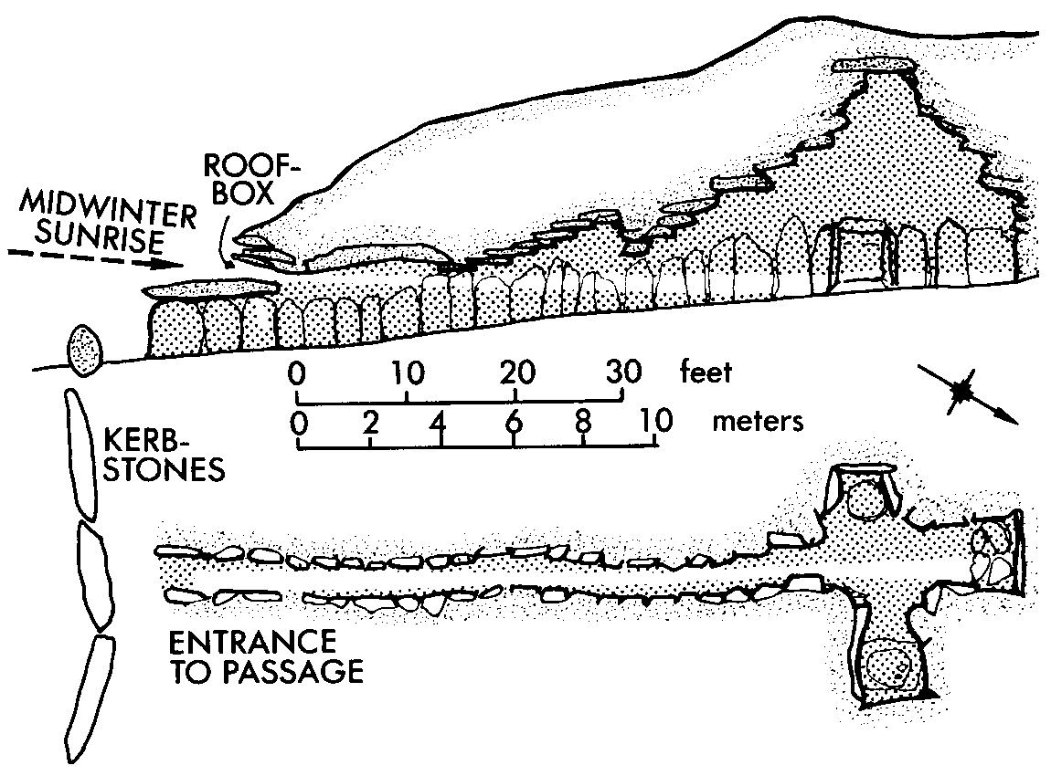
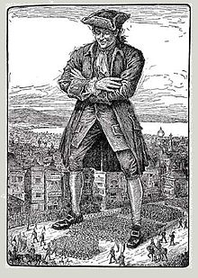
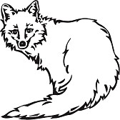
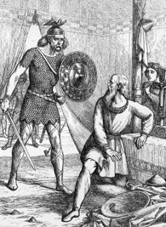
1: What is the name of Irish animation nominated for an Oscar in 2015? Song of the Sea.
2: Who visits the land of Lilliput on his travels? Gulliver.
3: What was Master McGrath?
A famous greyhound from the 19th century.
4: What do you call those parts of Ireland where Irish spoken? The Gaeltacht.
5: Where in Dublin are the Botanic Gardens? Glasnevin.
6: Where are Parnell. Daniel O’Connell, Michael Collins and Eamonn de Valera buried? Glasnevin Cemetry
7: Where are the executed leaders of 1916 buried? Arbour hill
8:What did ancient Romans call Ireland? Hibernia.
[Scotland-Caledonia England Albion.]
9:Why were there no settlers in Ireland during the Old Stone Age? Ireland was covered in ice.
10: Name the biggest Passage Grave in the Boyne Valley? Newgrange.
11: Ireland’s national theatre is located in Dublin. What is it called? The Abbey Theatre.
12: Where is the Ailwee cave located? Co. Clare.
13: What county do the Aran Islands belong to? Co. Galway.
14: Is Co. Meath a land locked county? No it is a maritime county.
15: Who according to legend caught the Salmon of Knowledge?
Finneagas. 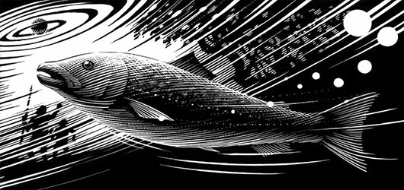
14: On which Scottish island did St. Colmcille found a monastery? Iona.
15: Which American General, along with all his men from the Seventh Calvary, were killed at the Battle of the Little Big Horn? General Custer. [Carlow man Captain Myles Keogh was also killed at this battle.]
16: What do you call a shallow place for crossing a river? A ford.
[Ath is Irish for Ford.]
17: Name the fruit of the blackthorn tree? Sloe.
18: What is a currach? A type of boat found in the west of Ireland.
19: Which Kildare town has a University? Maynooth.
20: What is the tallest building in Ireland?
St. John’s Cathedral Limerick.
21: What does YBIG refer to?
You Boys In Green. An Irish soccer fan club.
22: The Irish name for which Dublin building literally means
“ Bus House”? Busarus.
23: In which Irish city would you find City Hall in Donegall Square? Belfast.
24: On which side of the road do they drive on the Continent?
The right hand side. In Ireland and Britain we drive on the left.
25: What do the letters GPO stand for? General Post Office.
26: Katie Taylor has won one Olympic Medal –Gold- How many World Championships has Katie Taylor won? Five in a row.
27: What country is the ROI?
The Republic of Ireland.
28: Which Irish soccer player made FIFA’s best goal of 2014?
Stephanie Roche.
29: The American Secretary of State has the same name as an Irish county. What is his name? John Kerry.
30:Who won Ireland’s Fittest family in 2014? The Kingston family from Cork. Coaches: Claire bainisteoir Davy Fitzgerald and Olympic medal winning boxer Kenneth Egan alongside World Champion Hurdler Derval O'Rourke and Dublin legend Jason Sherlock.
31: Only one bridge over the Liffey is named after a woman. What is it’s name? Rosie Hackett
32:How many presidents has Ireland had including present president? Nine.
[Douglas Hyde, Sean T. O Kelly, Eamonn de Valera, Erskine Childers, Cearbhall O Dalaigh, Paddy Hillary, Mary Robinson, Mary MacAleese and Michael D. Higgins.]
33: What former leader of the DUP, also known as “The Big Man” died in 2014 ? Rev.Ian Paisley.
34: Which Irishman is responsible for Live Aid and the charity single “Do they know it’s Christmas ?” Bob Geldof.
35: Madra Rua or Red Dog is the Irish name for which wild animal? Fox.
36: What former Prime Minister in Britain was born in Dublin and earned the title “The Iron Duke” on the battlefield? Wellington. [Defeated Napoleon at Waterloo 1815]
37:Who was the first lady President of Ireland? Mary Robinson.
38: Which planet is furthest from the sun? Neptune
My Very Excellent Marster JUST Served Us Noodles. 8Planets
[Mercury Venus Earth Mars Jupiter Saturn Uranus Neptune.]
39: What is a Kerry Blue? A cow.
40:Who wrote the novel “Gulliver’s Travels” Jonathon Swift.
41: Where would you find the highest cliffs in Ireland?
Croaghaun (Irish: Cruachán) is a mountain on Achill Island, County Mayo, Ireland. At 688 metres, it has the highest sea cliffs in Ireland and Great Britain as well as the third highest sea cliffs in Europe (after Hornelen, 860 metres, Norway and Cape Enniberg, 754metres Faroe Islands) Slieve League in Donegal 601m.
42: What is Bressie’s real name? Niall Breslin
43:Who is the Carlow born presenter of Operation Transformation? Kathryn Thomas.
44: Which Irish singer had a hit with “Take me to the Church”? He also sang a duet with Annie Lennox at the Grammy Awards? Hozier.
45: Who is the present Bishop of Kildare and Leighin [Carlow]?
Fr. Denis Nulty.
46:Who is the current leader of Labour and Tainiste? Joan Burton. [Enda Kenny Tanoiseach and Leader of Fianna Gael. Michael Noonan Finance Jan O’Sullivan Education Frances Fitzgerald Justice]
47: Which sea would you cross if you took a boat from Dun Laoghaire to Holyhead? The Irish Sea.
48: What is the largest county in Ulster? Donegal.
Munster-Cork Leinster-Wexford and Connaught-Galway.
49: Where is Brian Boru buried?
The north wall of St. Patrick’s Cathedral, Armagh.
50:What world record number of international caps has BOD achieved? 141 caps.

